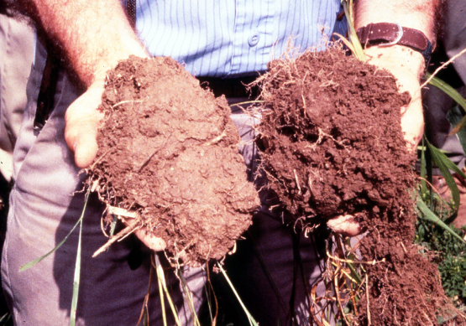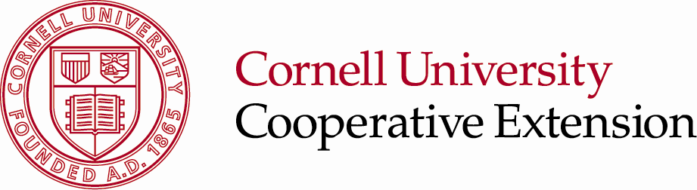

**Using Local Organic Amendments for Soil Health**

**Tuesday, March 25, 10 am to 3 pm**

**Spiritual Life Center, 575 Burton Rd., Greenwich**

(in the Great Room, Chapel building, follow the signs)

**Topics**

* Understanding Soils and Soil Health
* Interpreting a soil test analysis
* Compost and paper fiber by-products used for soil amendments
* How to read an analysis of organic soil amendments
* Properly using organic soil amendments to build soil health

**Speakers**

* Aaron Gabriel, Cornell Cooperative Extension
* Jean Bonhotal, Cornell Waste Management Institute

**Lunch is provided by our sponsors:**

**♦Casella Organics, Inc.**



**♦CTI-Agricycle**

**♦Environmental Soil Management Inc. of NY**

**♦Real Bark Mulch, LLC**

Please RSVP by Thursday, March 20 through CCE Washington Co, 518-746-2560.  Call Aaron Gabriel for details, 518-380-146, [adg12@cornell.edu](mailto:adg12@cornell.edu).